The Spring Scoop on Salamanders

Why are there so many salamanders in the spring?
It’s that time of the year again! Once the weather gets warm, and those spring showers show up, this is the time that salamanders awaken from hibernation and begin their migration process. Some species of salamander, like the spotted salamander (in the picture below), are also called “mole” salamanders because they will spend most of the year underground. For these species, the spring migration is one of the only times you’ll be able to spot them. When these little creatures migrate, they will travel as far as 100 feet!
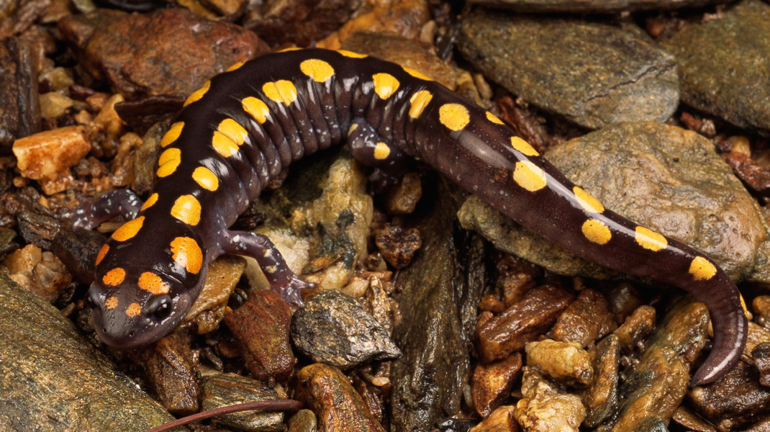
Where are they going, and why?
When salamanders migrate, they will head to a temporary wetland known as a vernal pool. These are small dips in the land that, during a wet season, will fill up with water. During the dry season, vernal pools will dry up again. This provides a perfect place for salamanders to lay their eggs because vernal pools will not stay wet long enough for fish to live in them, meaning there are less predators to threaten survival. Salamanders will use this opportunity during late winter and early spring to mate and lay eggs before scurrying back to their homes under and around the forest floor. Many salamanders will try to return to the same vernal pool that they were born in to lay their own eggs.
(insert picture of Joy vernal pool)
What exactly are salamanders?
Although they look a lot like lizards, salamanders and lizards are actually very different from each other! Lizards are classified as reptiles, which means a couple of different things. Reptiles have dry and scaly skin, and will lay hard-shelled eggs on land. Other types of reptiles include: turtles, snakes, and crocodiles. Salamanders, on the other hand, are classified as amphibians. Amphibians have smooth, moist, and porous skin, and will lay soft-shelled eggs in water. Other types of amphibians include: frogs, toads, and newts. Here are some more differences between reptiles and amphibians:

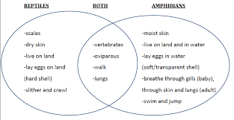

This means that salamanders are actually closer to frogs than they are to lizards, even though they look very different from each other. Just like with frogs, baby salamanders will go through a process called metamorphosis. This is a transformation from immature form to adult form that happens in two or more distinct stages. For animals that undergo metamorphosis, their young will look completely different from their adult form, and they will also survive in and interact with their environment very differently. Here is what metamorphosis looks like for a salamander:
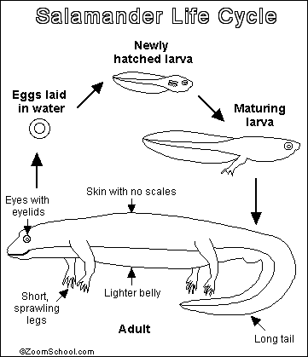
How Do I Find Salamanders?
Wait for spring! This is when salamanders will be coming out of hiding to breed.
Wait for rain or night! Salamanders are nocturnal, so they will be the most active at night. However, they will often come out on very rainy and cloudy days, too.
Find a wetland! Remember that salamanders spend most of their early life in the water, and even when they grow into adults, they will come back to a source of water to lay their eggs. Search around ponds, lakes, creeks, vernal pools, and rivers.
Look for bugs! Salamanders are carnivores, meaning they do not eat plants and can only eat other living prey. A salamander’s diet consists of various kinds of insects and worms, such as crickets, worms, larvae, spiders, and slugs. If you find these bugs, you may also spot a salamander hungry for a snack!
Check under logs, rocks, and leaves! Salamanders have to keep their skin moist to breathe, so they will try to stay out of direct sunlight as much as possible by hiding under and inside damp, shady areas.
Things to Keep in Mind…
While salamander hunting, there are some important things to keep in mind in order to protect the safety of the salamanders and their habitat:
- Watch your feet! Both salamanders and their eggs can be hard to spot, so be mindful about where you’re placing your feet, especially if you are searching around a wetland.
- That rock is someone’s roof! If you lift up a log, rock, or leaf to find a salamander, be sure to place it back where you found it so that you’re not possibly destroying an animal’s home. Do this gently to make sure you don’t crush anything living underneath. Just because you can’t see anything under a rock doesn’t mean that something isn’t there!
- Handle with care! Because a salamander’s skin is very porous, they are extremely sensitive to outside chemicals, including the salt in your sweat! The oils and other chemicals from your hands can really harm them, so if you can, try to avoid holding salamanders and admire them from a distance instead. If you absolutely must hold a salamander (such as to remove it from danger)…

  - Bring a clean disposable glove or sandwich bag to handle the salamander with.
  - Make sure the glove or baggie is wet to keep the salamander moist.
  - Make sure your hands and glove are free from sunscreen, perfume, bug spray, lotion, or any other chemical that could harm the salamander.
  - Keep salamanders low to the ground while holding them (just in case they were to fall!)
  - Be gentle—don’t squeeze or shake them.
  - Return the salamander to exactly where you found them.
  - Never grab a salamander by the tail. They will break off so that the salamander can escape. Although the tail can grow back over time, this leaves the salamander very vulnerable to predators.

- And lastly, have fun and learn something new! Salamanders are interesting creatures with unique characteristics, and there are many different kinds of species to observe. To make your hunt even more fun and challenging, try to identify all of different types, or species, of salamanders that you find.

If you live in Ohio (like Camp Joy does!), this is a helpful online guide on what kind of salamanders you can find. Click the link, print it out, and bring it with you on your search!
http://ohioamphibians.com/salamanders/Salamanders.html
If you live outside of Ohio, there are many free guides you can find on the internet based on your state. However, this guide below includes all species of salamanders; no matter if you live in North America, Mexico, or Canada! It is also interactive, so you can click on the characteristics of a salamander you find, and based on those, the website will calculate what species it is.
https://www.discoverlife.org/mp/20q?guide=Salamanders

Join Joy on Our Virtual Salamander Search!
(OE video)

HAPPY HUNTING!

