LIST OF PLANTS THAT GROW FROM CUTTINGS

MINT
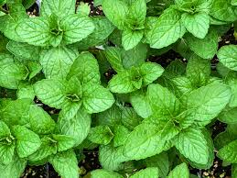
Mint is an herb that will grow almost anywhere its planted. With its soft stem, you can easily regrow a mint cutting in water. Once the new cutting has grown roots, transplant it into some potting soil and watch the herb grow.

Contains:
- Potassium
- Magnesium
- Calcium
- Phosphorus
- vitamin C
- Iron
- Vitamin A
Good for:
- Flavored water
- Iced tea
- Smoothies
- Ice cream
- Salad

SAGE
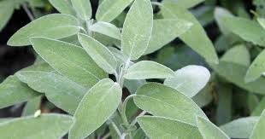
The best way to regrow sage is to take cuttings from a garden in the fall and pot it over winter, then repot it in spring. You can also try to grow roots in water from the leaf cuttings since it is a soft-stemmed plant.

Contains:
- Magnesium
- Phosphorus
- Potassium
- Folate
- Beta-carotene
- Vitamin A
- Vitamin K
Good for:
- Roasts
- Stews
- Pork
- Lamb
- Sausage
- Tomato sauce
- Stuffing

ROSEMARY
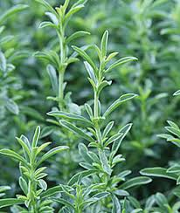
Rosemary will take over your herb garden if given the chance, so it's a great herb to start with if you want to try and propagate a plant. You can use new growth in the spring or basal cuttings in the late fall. The greener the stem is, the easier it will be to regrow new shoots.

Contains:
- Vitamin B6
- Magnesium
- Potassium
- Copper
- Fiber
- Vitamin A
- Vitamin C
- Folate
- Calcium
- Iron
- Manganese
Good for:
- Soup
- Casserole
- Chicken
- Steak
- Fish
- Stew
- Salad
- Potatoes

THYME

Regrowing thyme is exactly like regrowing rosemary. The two are even close enough that you can regrow them using the same jar of water (just make sure there's plenty of room in the jar).
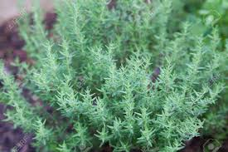
Contains:
- Vitamin C
- Vitamin A
- Copper
- Fiber
- Iron
- Manganese
Good for:
- Soup
- Sauces
- Potatoes
- Rice
- Bread
- Chicken

BASIL
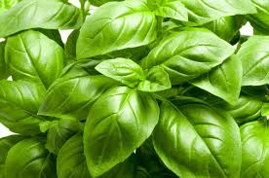
Basil is hearty and is an easy type of plant to regrow in water. It's best not to use basil that has flowered, and you'll want to take off most of the lower leaves with only the top clusters remaining.

Contains:
- Vitamin K
- Manganese
- Iron
- Vitamin A
- Vitamin C
- Calcium
- Magnesium
- Omega-3 fatty acids
Good for:
- Pesto
- Pasta
- Pizza
- Salads
- Soups
- Sauces

OREGANO
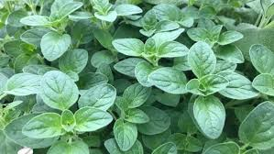
Another herb you can regrow soilless in water, make sure you remove any flowers as well as all of the leaves except the ones right on top.

Contains:
- Vitamin B6
- Potassium
- Copper
- Fiber
- Vitamin A
- Vitamin C
- Vitamin E
- Vitamin K
- Folate
- Calcium
- Iron
- Magnesium
- Manganese
Good for:
- Tomato sauce
- Pasta
- Pizza
- Lamb
- Chicken
- Beef
- Pesto

LAVENDER
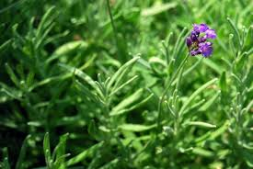
Cut three inches off the tip of the lavender plant. If you take the stem cuttings in the spring, you'll want to give them at least four to six weeks to grow new roots before you plant them in a garden bed. You can also take cuttings in the fall to replant in the spring.

Contains:
- Vitamin A
- Calcium
- Iron
Good for:
- Iced tea
- Lemonade
- Cookies
- Ice cream
- Cake
- Cupcakes
- Muffins
- Soap
- Perfume
- Candles
- Lotion
***When cooking with lavender, a little goes a long way! If you use too much, your food will taste like soap or perfume.

